

EXECUTIVE SUMMARY

Baltimore’s public schools are failing. Enrollment is falling precipitously. City school buildings are, on average, twice as old as facilities everywhere else in Maryland. Every year children languish in classrooms without air conditioning and shiver in classrooms without heat. Violence, health hazards, and low expectations follow our kids into the classroom.

Far too many of Baltimore’s schools are divided by race and class, just as they were before *Brown v. Board of Education*, the landmark Supreme Court decision fought and won by a native son of Baltimore, Thurgood Marshall, that promised the end of segregation in schools. We have broken the promise of Brown. Baltimore schools do not provide the equal public education imagined by Justice Marshall -- they are not worthy of the city that raised the young man who would become one of the greatest Justices in American history.

We must fully fund the Kirwan Commission's proposals. That said, there are additional systemic and external factors that have held our schools back and demand sweeping reforms. We cannot rely on Annapolis to put forth all of the solutions. Thiru Vignarajah’s Education for All plan offers a roadmap to transform city schools into centers of learning that we could be proud of. Repairing broken schools may take a generation, but these are concrete steps that will raise expectations for our children's education.

**Counteract Declining Public-School Enrollment & Keep Students in Public Schools**

1. Deliver free universal pre-k for three- and four-year-old children
2. Guarantee debt-free college for every graduate of a Baltimore City public school at any institution in Maryland, including community colleges, trade schools, and public and private universities

**Reimagine the Role of Public Schools in Community Life**

1. Create a Deputy Mayor for Education to ensure interagency cooperation
2. Transition all K-8 public schools into community schools, allotting $1 million in funding for community school coordinators and programming at each school
3. Replace School Family Councils with Local School Boards focused on parental and community engagement
4. Follow the example of Indianapolis to become the second city in America to grant mayoral authority to approve charter schools, in order to expand choice options
5. Increase the flow of charter school funding from central administrators to charter school operators
6. Normalize extended-day and year-round instruction

**Improve the Quality of Education Delivered in Baltimore’s Schools**

1. Renovate crumbling infrastructure and install HVAC systems in all schools without one
2. Increase teacher recruitment and retention with advancement opportunities
3. Place an extra adult resource in every classroom at schools with the highest need
4. Prioritize restorative justice and redirect school police officers out of classrooms and into communities
5. Equip administrators and educators with the resources and training required to offer consistent, personal trauma-sensitive support and instruction
6. Expand programs for enterprising students to accelerate their education with trade school instruction, university-level coursework, or apprenticeships during their junior and senior year of high school
7. Prioritize student advocacy in the development of individualized education plans
8. Offer stipends to local artists and musicians who will devote time to schools lacking art and music programs
9. Launch financial literacy educational programs in all high schools

**Close the Digital Divide and Provide Online Learning Access**

1. Provide electronic devices conducive to digital learning to households in need
2. Guarantee high-speed internet access in all neighborhoods

**How do We Pay for It?**

1. Cannabis taxation and regulation
2. Public-Private Partnership
3. Budget Reprioritization

**Counteract Declining Public-School Enrollment & Keep Students in Public Schools**

Student enrollment in public schools continues to decline; this is both a cause and consequence of our system’s struggles -- from relentless crime to poverty to homelessness. Our commitment to universal pre-k and debt-free college for city high school graduates will not only benefit the students, but will also encourage families planning to move out of Baltimore City public school districts to reconsider their decision. Fostering an academic environment competitive with surrounding counties and boosting enrollment numbers are key to **changing the perception and reality of Baltimore schools.**

* 1. **Guarantee free universal pre-k for three- and four-year-old children**

The achievement gap between Baltimore City Public School (BCPS) students and students in surrounding county school districts is evident early on, and the disparity increases as they grow older. In 2022-2023, testing revealed that only 42% of Baltimore City kindergarteners’ test scores reflected adequate preparation for kindergarten, and readiness was significantly less common among children of immigrant parents, children with disabilities, and children from low-income households. In fact, only one- third of low-income students were reported to be prepared for kindergarten. These disparities, while present throughout the state, are significantly intensified in Baltimore City.

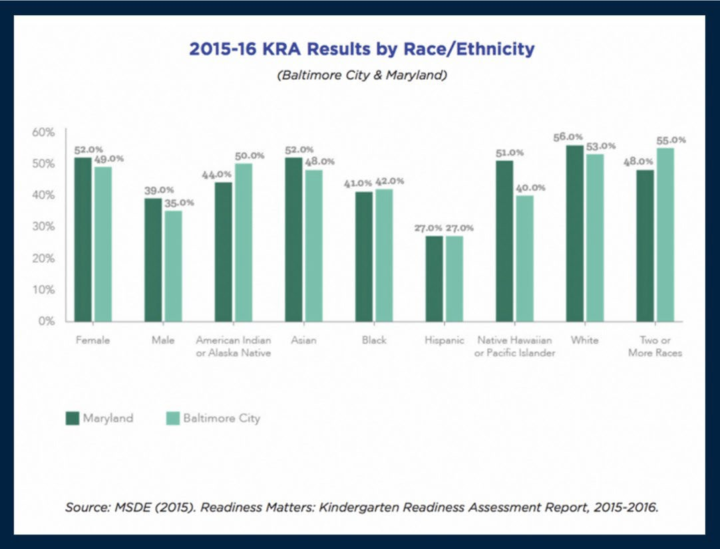

Graphical Update needed

Without access to high quality pre-k, students arrive in kindergarten already behind their peers. It is difficult to play catch-up. Universal pre-k for three and four year-olds provides a substantial initial advantage in academic achievement and the investment in early education compounds year after year. This is a trajectory that will improve the collective cultures of our elementary grades and all subsequent school years. Baltimore City will become the next jurisdiction to guarantee free, universal pre-k for all three and four-year- olds. Cities like Tulsa, Philadelphia, and Washington D.C. have seen tremendous success in their respective early education programs, with lasting educational results well beyond elementary school.

There are proven benefits to universal pre-k that will accelerate students’ socio-emotional

development, academic skill sets, and address larger community issues. The gains in

achievement children acquire during pre-k correlate with lower crime rates, higher lifetime

earnings, and better health prospects. In the short-term, guaranteeing universal pre-k

dramatically reduces family expenses and has increased the number of women, especially

women of color, returning to work sooner than otherwise possible after childbirth. In

Washington, D.C., the labor force participation rate for low-income mothers increased

dramatically from 40% to 55% after the implementation of universal early education.

Offering universal pre-k will also encourage families to stay in Baltimore even once their

children move onto their K-12 education. Pre-k begins to foster collective parental

engagement, through which parents and families become connected and invested in their

children’s education. These bonds promote parental advocacy in the school system and

strengthen communities. Collective parental engagement beginning in and centered around

pre-k can become a key factor that families consider in their choice to keep their kids in

Baltimore City schools instead of relocating to neighboring counties, seeking to retain the

structural support formed at the onset of their child’s education. Implementing universal pre-

k is crucial in bolstering continual enrollment into city public schools, subsequently increasing

state-allocated education funding, part of which is directly tied to student population.

Baltimore City currently uses a priority system in order to determine which children are

eligible for city-funded pre-k and enrollment is limited. Children must reach the age of four

by September of the school year if they wish to be enrolled and must be considered low

income, homeless, or in need of special education services in order to qualify under Priority

1 status. Even if a child is considered Priority 1, space is not guaranteed. Our plan for

universal pre-k eliminates this inconsistency and ensures equal educational opportunity

entering kindergarten.

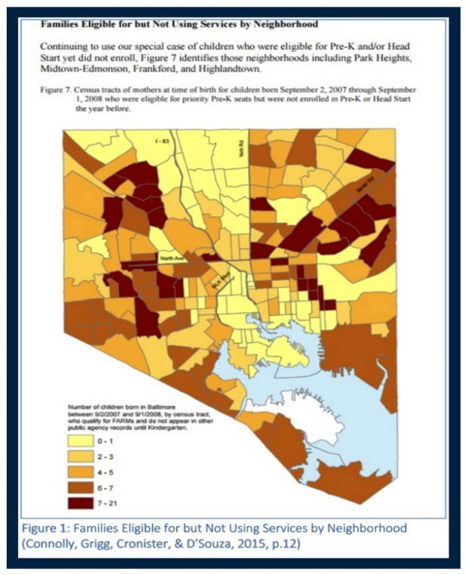These programs are only as meaningful as their

accompanying outreach programs are

effective. Pre-existing programs, such as Head

Start, have been massively underutilized in

Baltimore City. In a longitudinal study for 9,694

children born in Baltimore City, the Baltimore

Educational Research Consortium found that

there was low enrollment among qualifying

children who live in areas that have seen historic

disinvestment and that have predominately

black populations.

We will launch targeted outreach programs in

these communities to inform parents and

caretakers of the city’s free 3/4 pre-K program,

partnering with local health institutions, faith

organizations, libraries, and community

stakeholders.

* 1. **Guarantee debt-free college for every graduate of a Baltimore City public school at any institution in Maryland, including community colleges, trade schools, and public and private universities**

Baltimore City’s investment in our children cannot end at high school graduation. Baltimore will make college or trade school at any institution in Maryland (including tuition and room and board) debt-free for every graduate of a Baltimore City public high school. This will make Baltimore City the first jurisdiction in the United States to guarantee both tuition and room and board at any state institution. Under this plan, graduates of Baltimore City public schools will be entitled to one debt-free year of college education at a Maryland institution for each year they complete in a Baltimore City public high school. Thus, a student who attends four years of a city school will be entitled to a corresponding four years of continued education. The promise of debt-free college is a promise to our kids that we believe they can succeed.

Providing this incentive for every graduate of Baltimore City public high schools is likely to

increase both graduation rates and school funding. Baltimore City has long suffered

graduation rates much lower than its surrounding counties and the rest of the state. In 2021-

2022, the Baltimore City high school graduation rate was 68.65%; comparatively, the high school

graduation rate for Maryland was 85.81% (2023). As enrollment increases in response to the

promise of debt-free higher education, funding for schools will subsequently increase. Debt-

free college education will remove a financial barrier that may prohibit young adults from

contemplating the opportunities that higher education presents.

This is certainly an investment, but it is also not as expensive an investment as one might

think. First, collegiate enrollment rates among graduating seniors is low; in 2015, only 43.6%

enrolled in either two-year or four-year higher learning institutions and only X students

graduate from Baltimore City public schools each year. Second, the cost of college is

relatively low when considering substantive financial aid grants and the city’s pre-existing

collegiate financing programs. Community colleges are already free, and cost

approximately $6,044 per student per year; and the in-county average tuition is $4,324.

Similarly, trade schools average at $6,536 per student per year, in-state tuition for public

universities in the state of Maryland range from $15,522 to $24,051 per person per year,

and even private universities, which can be much more expensive, offer significant financial

aid, especially to students of Baltimore City, many of whom face significant financial

hardships.

**Reimagine the Role of Public Schools in Community Life**

1. **Create a Deputy Mayor for Education to ensure interagency cooperation in support of city schools**

A new Deputy Mayor for Education will be responsible for ensuring that every city agency is doing its part to make sure that our kids are educated. From ensuring equitable and safe public transit options to schools to increasing affordable housing options, this position is all about a holistic governmental approach to transforming public schools and depends on strong leadership, beginning with the Mayor and Deputy Mayor for Education.

1. **Phase all K-8 public schools into community schools with $1 million in funding for community school coordinators and programming at each school**

Elementary schools can serve as far more than places where students go to learn. When transformed into community schools, these spaces are cornerstones of community life— enhancing the lives of children, their families, and older adults in their area through a range of educational, developmental, and cultural initiatives. Most models that employ schools as community centers revolve around a trained, local facilitator who coordinates and manages a variety of engagement initiatives and programs that take place outside of school hours. While many of these initiatives focus on supporting families with young children, the model operates on the premise that “it takes a village” to raise a child. Healthy communities lift their students towards brighter futures, and coordinators understand serving everyone, from grandparents and local business owners to young adults, helps children succeed.

Community Schools will offer:

1. Free extracurricular and after-school care for children under 12 who are currently eligible for free or reduced lunch

We will partner with local community centers, childcare providers, and nonprofit organizations to extend extracurricular activities and care to all students currently eligible for free or reduced lunch. These will serve to help our students build meaningful relationships and to keep them engaged in extra hours of instruction.

1. Parental support groups and adult education classes (ex. cooking, financial literacy & language training)

To encourage collective parental engagement surrounding schools, we will offer school- sponsored parental support groups with opportunities for educational classes and workshops. These opportunities will include services ranging from financial literacy, language training, and resume building to cooking, fitness, and parenting. Opportunities to earn a GED will also be streamlined through community school programs.

1. Offer basic healthcare services

We will facilitate partnerships with nonprofits and local health institutions to offer free yearly health and wellness screenings at all public elementary schools. Students will be tested for vision and hearing, BMI, lead exposure, and trauma, then provide the necessary resources for further treatment, if needed. City Hall will impose a 50%

wholesale tax on vaping products, plus an additional $0.10/mL tax on e-liquids containing nicotine, with the proceeds directed to these health screenings as well as youth prevention efforts and treatment for those addicted.

1. Night-time recreational programs for teens and young adults

Community schools offer an opportunity to keep our kids off the streets. Especially in communities most vulnerable to violence, these initiatives are critical to investing in the futures of our youth. In partnership with local faith and nonprofit organizations, we will offer free night-time recreational programs for teens and young adults.

1. Low-cost space for neighborhood events, holidays, and other gatherings

To make these centers successful, community coordinators will work with the area’s pastors, principals, parents, and other community leaders to integrate expanded programming into the 48 public elementary schools in Baltimore City. Especially as funding for parks and recreation in Baltimore continues to decline, the importance of these kinds of integrated initiatives only continues to grow.

Funding directed towards community schools will be allocated on a need basis, so our neighborhoods and schools most in need of support receive immediate assistance. The Deputy Mayor for Education and CEO of Schools will launch a collaborative asset mapping effort to divert resources where they are most critically needed.

1. **Replace School Family Councils with Local School Boards focused on parental and community engagement and student leadership**

Currently, Baltimore City Public Schools requires that each school maintain a School Family

Council (SFC) composed of the principal, assistant principal, teachers, parents and community

members. The SFC's duties include: (1) establishing/maintaining committees such as

Attendance, Climate & Safety, Family and Community Engagement, (2) collaborating with

the principal and Instructional Leadership Team to implement the school performance plan

(SPP), (3) providing feedback to the CEO of Schools on the proposed school budget and

SPP, and (4) assisting the Office of Human Capital with the principal selection process, in the

case of a vacancy. We propose that a more inclusive and community-based model be

implemented through the institution of Local School Boards (LSB) in each elementary, middle,

and high school, which has proven effective in cities such as Chicago.

Local School Boards will consist of the principal, six elected parents, two elected community

representatives, two elected teacher representatives, one elected non-teacher staff

representative, and, in high schools, one elected student representative. The LSB will take a

more active role in the approval of budgets and administrative contracts, not just simply

make recommendations, and evaluate the execution of the SPP, including the effectiveness

of administration and teachers in a report submitted to the CEO of schools and Deputy

Mayor for Education. In high schools, the student representative will have a critical role in

voicing student concerns over the academic climate and student safety within the school, as

well as speaking to community issues affecting youth.

In elementary schools, working within the community school model, LSBs will coordinate with

community stakeholders and philanthropic actors to tailor programs and resources to the

specific needs of each school’s and surrounding neighborhood’s unique needs.

1. **Following the example of Indianapolis, become the second city in America to**

**establish mayoral authority to authorize charter schools, in order to expand public**

**charter school options**

To make these centers successful, community coordinators will work with the area’s pastors, principals, parents, and other community leaders to integrate expanded

Baltimore’s public charter schools time and time again have proven to produce stronger academic results than their traditional school counterparts. In a 2019 study of Maryland’s urban charters, students experiencing poverty gained an additional 30 days of math achievement per year and Black students gained an additional 47 in math achievement per year and 41 days in reading achievement. For students on the cusp of falling behind or who already have felt the effects of inadequate early education and failing schools, these gains cannot be understated.

We will support the expansion of charter schools in Baltimore City by first following the lead of Indianapolis to establish sole mayoral authority for charter school authorization without interference on state levels. This action streamlines the application process and accelerates approval/authorization, ensures transparency in the approval of charter schools, and establishes open lines of communication between the political and financial players as well as neighborhood organizations and community stakeholders. City Hall has tremendous access to capital and philanthropic resources to not only expand Baltimore’s existing network of public charters, but monitor their success and strategically allocate

resources in schools. Indianapolis has seen incredible success in their public charters

following the implementation of mayoral authorization authority. In the 2006-2007 school

year, the Mayor's Office presided over 16 public charter schools. All 16 schools met or

exceeded adequate yearly progress standards, compared to 38% percent of Indianapolis

Public Schools' traditional counterparts.

1. **Increase the flow of charter school funding from cental administrators to charter school operators charter school operators to ensure the funding and independence they require to succeed**

We will commit to directly support charter school operators with the financial means they need, largely circumventing the arduous process of approval from central administrators. This action grants charter school operators with the independence to make rapid and critical decisions about how money will be best spent in their classrooms and in their communities at a much faster pace with an ear to the ground.

1. **Establish schools offering extended-day and year-round instruction**

Studies have shown that students in programs with extended school days perform better academically, and that these gains are even more prominent in previously low-performing schools with economically disadvantaged children. We will establish select schools in underinvested neighborhoods to offer extended day and year-round instruction for interested students and families with the intention to scale.

**Improve the Quality of Education Delivered in Baltimore City Schools**

1. **Renovate our schools’ crumbling infrastructures and install HVAC systems in every school without one**

Too many of Baltimore’s schools have crumbling infrastructures, from leaky roofs and

fractured foundations to insufficient heat and air conditioning systems. Substandard facilities

are not only harmful to our students’ health and safety, they are disrespectful to the children,

the families, community and the culture at-large. These capital improvements cannot be

borne by individual schools and must be part of a comprehensive investment by the city

(and the state) in the future of education in Baltimore. We plan to construct a City fund to finance discretionary maintenance and renovation, allocating more money towards updated

educational materials.

We hear our kids tell us how difficult it is to focus when they are sweating or shivering in

classrooms. Year after year, we see identical headlines lamenting students sent home early

when the weather turns especially hot or especially cold. A Johns Hopkins Study concluded

that school closings due to inadequate facilities have resulted in 1.5 million educational hours

collectively lost. In city schools with the largest achievement gaps, which often have student

populations with disproportionate amounts of students of color and low-income students, this

lost classroom time is even more detrimental. One Harvard study determined that the

difference in exam performance on a 90 degree day compared to a 72 degree day results

is equivalent to a quarter of the Black-White student achievement gap.

1. **Increase teacher recruitment and retention with advancement opportunities**

With hundreds of teachers leaving Baltimore City Public Schools every year, Baltimore faces a serious teacher shortfall that negatively impacts students’ quality of education and teachers’ quality of work.

Johns Hopkins and American University researchers determined that black students who are

exposed to one black teacher by third grade were 13% more likely to enroll in college,

and those who had two black teachers were 32% more likely to enroll in college. To ensure

that more students of color are taught by teachers of color, we will lead teacher recruitment

efforts at the incredible HBCUs that reside in and surround our city to build a diverse, local

staff of educators. Just as we have promised for law enforcement, we will offer automatic

qualification for the dollar homes program to all teachers that pledge to remain in the city

public school system for at least five years.

Educators should be compensated and treated in a manner befitting the crucial role they play in society. In order to combat teacher shortfalls, we need to make the position more competitive, appealing, and growth-orientated. Teachers should receive opportunities for advancement and collaboration throughout their careers. If we elevate the teaching profession, we will expand the pool of talent pursuing teaching as a vocation.

1. **Place an extra adult resource in every classroom at schools with the highest need**

Countless studies have proven the benefits of co-teaching and additional student-teaching resources, especially in high-need classrooms. Another authoritative figure, even if not another teacher, allows the primary teacher to teach without having to interrupt to discipline or regain control, resulting in more instructional time. Two adults in every classroom also presents the opportunity for individualized learning for students who need it, increasing both teacher and student morale and boosting educational outcomes.

Recruitment efforts to hire extra adult resources will be centered around outreach to present and former substitute teachers, parent volunteers, paraeducators, and student teachers from surrounding colleges and universities. We will coordinate with schools of education especially at HBCUs to focus on creating a pipeline to student teaching in city schools, citing the fact that Black students who have one Black teacher are more likely to go to college.

1. **Prioritize restorative justice and redirect school resource officers out of classrooms and into communities**

Disciplinary actions by schools must consider the safety of all students, teachers, and school employees. However, removing students from schools should be the option of last resort. The code of conduct fails to provide alternatives to suspension that address the root cause of the behavior that prompted the suspension. This requires a holistic approach that recognizes the complexities of a student’s behavior and provides alternative outlets and resources. By investing heavily in community schools’ creation and expansion, we can connect some of Baltimore’s most disadvantaged families and children to resources, training, childcare, and other social services. Across all schools, teachers and staff must be trained to implement restorative justice practices, like those that have flourished at, for example, City Springs Elementary. Restorative justice establishes a framework to deal with a crisis before the crisis happens by encouraging students to discuss problems in a safe and constructive manner. This is a superior alternative to disciplinary actions in many cases.

The presence of police in our schools promotes this culture of strict discipline and only reinforces the generally negative relationship between Baltimore’s youth and law enforcement. We pledge to remove school resource officers from campuses and redirect them to neighborhoods with the highest need.

1. **Equip administrators and educators with the resources and training to offer trauma- sensitive support and instruction to students**

Too many students in Baltimore City have been exposed to violence. Public schools need to not only be equipped with adequate instructional resources, but also with trauma sensitivity training. We plan to transform all Baltimore City public schools into trauma-sensitive schools with mental health and counseling resources for students who face violence in their lives and neighborhoods. This requires expanding, embracing, and fully funding trauma-based care and restorative justice practice. To do this, training and professional development surrounding trauma-sensitive disciplinary policies and mental health will be extended to all staff and faculty. Opportunities for families and communities to gain education about coping with trauma will be provided as well. There will also be an increase in staffed counselors and psychiatrists that will assist in many students’ transitions to school. An extra adult in the classroom will serve to help integrate children affected by trauma into the classroom instead of having to isolate them further.

1. **Expand programs for enterprising students to accelerate their education with trade school instruction, university-level coursework, or apprenticeships during their junior and senior year of high school**

Expanding programs geared to all facets of enterprise and academic achievement must be prioritized. More opportunities for vocational school instruction, collegiate coursework, and internships/apprenticeships will be made more readily accessible to students completing their junior and senior years of high school. This effort will be supplemented by harnessing students from the thirteen colleges and universities in and surrounding Baltimore, which over 550 city public school graduates enroll in each year, to serve as educators and mentors.

1. **Offer stipends to local artists and musicians who will devote time to schools whose art and music programs have been suspended**

Officials faced with constricted school budgets often resort to suspending art and music programs, which offer indispensable aspects of cognitive development and are beloved by students. Introduction to the arts is even more important to the city’s many students who have been exposed to trauma. We propose giving stipends to local artists and musicians who choose to pledge their time teaching in schools with suspended art and music programs.

1. **Prioritize student advocacy in the development of IEP plans**

Students with learning disabilities and other educational challenges deserve a say in the creation of their mandated individualized education plans (IEPs). Parents and educators have dominated the conversation without safeguards to ensure that students can work collaboratively with staff to best equip them for graduation and beyond. We will hire designated Individuals with Disabilities Education Act (IDEA) advocates to stand alongside students as representatives during IEP proceedings. Bilingual advocates and interpreters will also be available for families who request their services.

1. **Launch financial literacy educational programs in all high schools**

Especially given the unprecedented economic strain presented by the COVID-19 pandemic, individuals are facing higher unemployment rates than ever before and families are struggling disproportionately in Black and Brown neighborhoods. In a 2017 study, 32% of Black households in Baltimore City have $0 or less in net-worth, and, while representing approximately 63% of the population, Black residents earn the lowest household income of all races: $33,801. Eliminating the racial income divide requires a quality K-12 education, accessible higher learning opportunities, an inclusive job market, and information on financial literacy.

According to a 2018 FINRA survey, when asked six questions covering fundamental concepts of economics and personal finance, African American participants scored lower than any other race, with an average of 2.3 correct answers out of six.

To level the playing field, Thiru will implement the following initiatives:

* 1. Boost citywide participation in the SIFMA Foundation’s “The Stock Market Game.”

The Stock Market Game helps students build a fundamental understanding of investing while providing them with real world skills practice in math, English Language Arts, economics, social studies, and other subjects. Teachers do not need to be an expert or experienced trader to lead lessons due to the extensive tutorials and supportive resources. The Maryland

Council on Economic Education provides free training throughout the year for first-time users

of the Stock Market Game as well, and sponsors a state-wide awards program in May.

As of the latest estimates, there are 38,102 6th-12th grade students enrolled in Baltimore

City public schools. If every student participated in the year-long game the cost would be

$1,143,060; a 50% participation rate would result in a $571,530 annual expense — this

is minimal in the broad sense of our educational budget. Thiru is committed to making this

resource available to all middle and high school teachers and students.

* 1. Provide free virtual monthly financial seminars

We are committed to improving Baltimore City school’s transition to virtual learning, using free virtual financial literacy seminars to bring us up to speed. By offering these free monthly learning opportunities, the city will not only be able to offer another tool for both students and their parents to increase their understanding of smart money management and investing, but it will also serve as a testing base for virtual learning. City Hall will coordinate with local non-profits to secure funding for learning sessions.



1. **Provide electronic devices conducive to digital learning to households in need.**

In 2018, the National Digital Inclusion Alliance ranked Baltimore the 60th worst-connected city in America in

a study of households without any broadband internet. It found that 21.96% of Baltimore households, or

52,084 families, were without broadband internet access of any kind.

To bridge this divde and ensure equal access to online learning, we will designate funding to pay for the

purchase and distribution of laptops and internet to families. The city should also partner with philanthropic

and community organizations to set up a fund for lightly-used laptops that can be refurbished and distributed

to families in need.

1. **Guarantee high-speed internet access in all neighborhoods.**

The Digital Harbor Foundation recently partnered with the Baltimore Robotics Program to provide free community wifi in southwest Baltimore. City Hall should fund initiatives like theirs and propel them to a broader, citywide scale. Looking to the future, we will partner with broadband internet providers to offer free or significantly reduced-priced essential services to low-income households without access. This action will ensure universal internet access across the city to not only educate our children in this time of virtual learning, but also ensure that adults have the resources to apply for jobs and play their bills in an era of unprecedented economic uncertainty.

**HOW DO WE PAY FOR ALL THESE UPGRADES AND REFORMS?**

*Cannabis taxation and regulation.* In 2018, the State of Colorado generated over $80 million in sales tax

revenue and another $178 million in retail tax revenue from the cannabis industry. Since legalization, the

wholesalers, dispensaries, and their customers have delivered over a billion dollars in additional funding for

needed educational programs, school infrastructure projects, and mental health across the state. Baltimore

and Denver have near identical populations and usage rates, and the medical cannabis industry in Maryland has grown exponentially in recent years. It’s not unreasonable to expect a similar funding boom for Baltimore, should we move forward with recreational legalization. By our most conservative estimates, Baltimore should expect the same $30 million dollars in funding for education programs that Denver receives on a per capita basis each year. If we further apply a modest tax on transactions between wholesalers and dispensaries within the city of Baltimore, we can expect another $3-5 million in revenue each year.

Cannabis has the potential to offset many of the funding deficits facing the city of Baltimore, but we need a Mayor who can work with the Governor and City Council to ensure Baltimore’s kids receive their fair share.

*Public-Private Partnerships.* Spending on education, particularly pre-k-8 schools and programs, has the highest return of any investment in public goods or services. Education spending is about investing now with low-cost capital now to generate future tax revenue and savings in areas like health and criminal justice. We need Mayoral leadership capable of securing outside funding for investments like universal pre-k that can pay for itself. There are $19 in near-term savings per $1 invested in pre-k and up to $38 savings in possible long-term savings and additional tax revenue. Our lack of pre-k and k-8 programming is not an issue of inadequate funding, it is an issue of inadequate leadership.

Using available social financing tools and creative debt financing, Baltimore can rebuild, revitalize, and reimagine its education system with funds from an array of private sources. We need a Mayor with the ability to explain the potential of Baltimore to investors across the world, and one with both the legal and business acumen to ensure the financial position of our city remains healthy and sustainable in the process. In

his first term as Mayor, Thiru will capitalize on our city’s AA credit rating, raising 100 million dollars in private philanthropic capital for education, and exploring unique social financing options with impact investors and banks across the country to invest in the future of Baltimore schools.

*Reprioritization of the Budget.* Point blank, there is wasteful spending in City Hall. We will audit the city’s spending, and where necessary, make the hard reallocation decisions to make sure our kids are our city government’s top priority. We need a Mayor who understands the relationship between education spending, crime reduction, and economic development.

**CONCLUSION**

Justice Thurgood Marshall wrote, “Unless our children begin to learn together, there is little hope that our people will ever learn to live together and understand each other.” We must guarantee the implementation and full funding of the Kirwan Commission recommendations. We must recruit, retain, and value great teachers and principals and librarians; we must incorporate restorative justice practices into the standard curriculum of city schools; and we must erect world- class facilities all across the city where students can succeed. The Education for All Plan is meant to create schools that parents of every background want to send their children and where children of all circumstances can thrive.

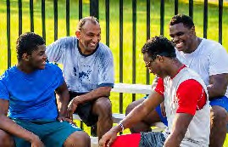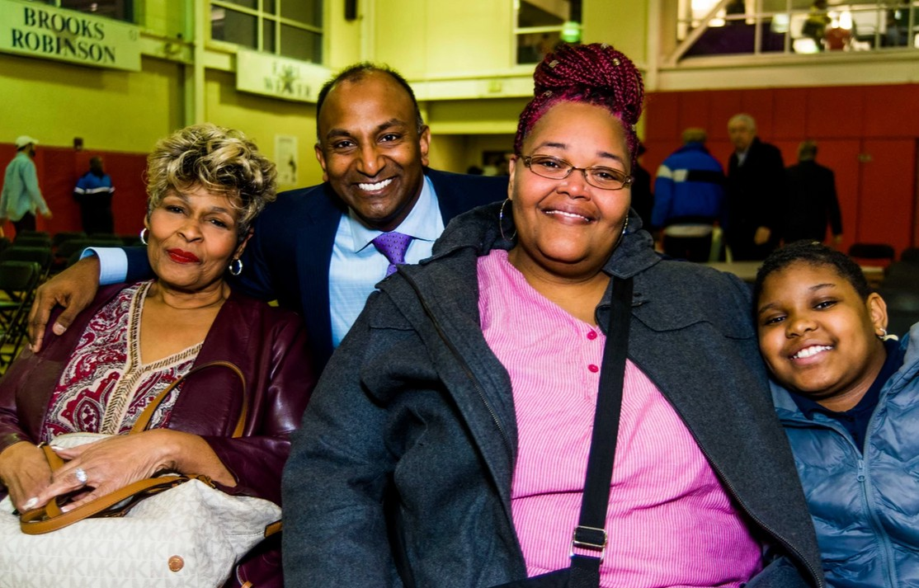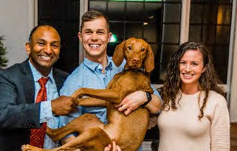

A BALTIMORE BLUEPRINT FOR EQUITY, TRANSIT, HEALTHCARE, IMMIGRANTS & THE ENVIRONMENT

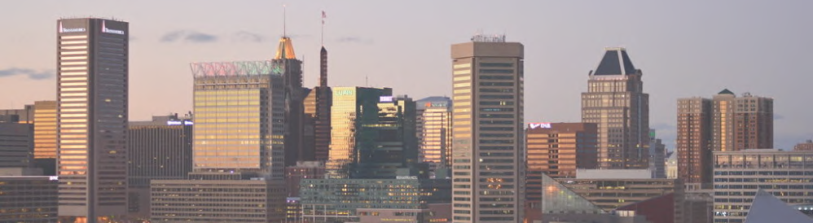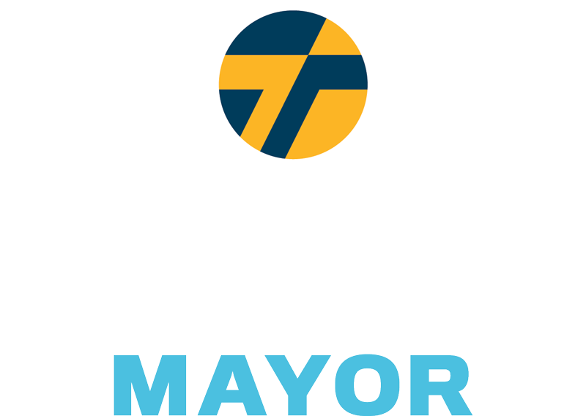

*OPEN BOOKS BALTIMORE*

Baltimore mayoral candidate Thiru Vignarajah recently announced "Open Books Baltimore," a commitment to make City Hall more transparent than it has ever been before. As mayor, Vignarajah pledges to:

Launch a citywide forensic audit to be shared with the public within 100 days of taking office

Establish monthly public CitiStat, with three citywide town halls and nine town halls in each police district

Hold a weekly press conference on the state of crime in Baltimore

*"You will know what I know."*



**Root Out Corruption: Thiru’s Plan to Restore Trust in City Hall**

Baltimore has seen a state senator, a city aide, multiple police officers, two police commissioners, and now two

Mayors charged and convicted of public corruption. When former Mayor Catherine Pugh recently pled

guilty, we learned that the latest public corruption prosecution in Baltimore was not the result of an

accounting error or negligent oversight — it was a calculated and deliberate conspiracy driven by the City’s

career politicians seeking money and power rather than striving to serve the public. Enough is enough. This

must end, and it must end now.

Thiru’s plan to root out corruption attacks three intertwined evils: career politicians seeking to get rich and stay in office

rather than serve the public; a culture of nepotism where politicians appoint family and friends—and the

family and friends of their allies; and a pay-to-play system where lobbyists and big money enable the rich

to buy off politicians and buy their way into office.

Baltimore deserves better. Along with releasing his anti-corruption plan, Thiru has committed to a series of pledges and called on all other mayoral candidates to do the same. The people of Baltimore need to be reassured that those who seek to lead them are aware of the lack of faith in City Hall and are prepared to make the commitments needed to restore trust in local government. Highlights of the plan include:

* A charter amendment requiring candidates for city office and any appointee requiring confirmation by the City Council (e.g., the police commissioner) to release 5 years of tax returns. Thiru is still the only mayoral candidate in Baltimore history to release five years of full tax returns.
* A mandate that city elected officials obtain an ethics opinion before accepting any new source of supplemental income over $10,000 and promptly disclose that income to the public.
* A prohibition preventing elected officials from serving as lobbyists for 3 years after their term ends.
* A rule against appointing a family member or employee of an elected official to a vacant elected office.
* A condition that elected officials publicly disclose the existence of a family or business relationship whenever making a personnel recommendation for a position in city government.
* A criminal ban on campaign contributions by registered lobbyists and on any company soliciting donations from its vendors for more than an aggregate amount of $6,000.
* A requirement that any outside loans to a campaign after the final reporting deadline just before a primary or general election be disclosed to the public within 12 hours.
* A 50% tax on personal contributions exceeding $250,000 to one’s own campaign, the proceeds of

which would go to a public fund for opponents with 10,000 signatures or $250,000+ in donations.

Thiru is also committed to transparency once in office in order to keep leadership directly accountable for the state of Baltimore. Once elected, he has pledged to:

* Launch an independent citywide forensic audit of all agencies to be shared with the public within 100 days of taking office.
* Establish monthly public CitiStat for real-time accountability, and hold three citywide town halls per year and a town hall in each of the nine police districts.
* Hold a weekly press conference on the state of crime in Baltimore.

Public office in Baltimore must be earned, not bought. It’s time to root out corruption, to make sure elected officials are accountable the public’s interest above all, and to end nepotism and City Hall’s pay-to-play culture once and for all.

### The Only Baltimore We Have

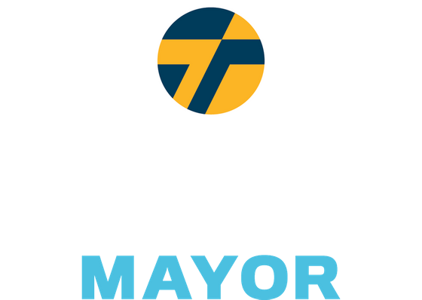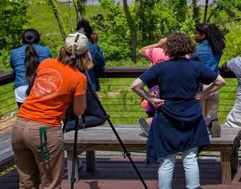

***Baltimore has an opportunity to reimagine its role in battling the defining challenge of our generation.***

***This will require City leadership, regional cooperation, and global innovation. As Mayor, Thiru will:***

##### Close the Incinerator

Baltimore will shut down the incinerator by permanently ending our contract, working with the County

to pressure Macquarie to replace the incinerator with a mixed-waste materials recovery facility (MRF), and develop a true circular economy around it.

##### Expand the Tree Canopy

Baltimore will expand its tree canopy from 27% to 40% in 10 years, integrating this commitment in city

schools and creating workforce development opportunities for trade schools in landscaping.

##### Clean the Streets & Waterways

Across our city, you will encounter overflowing trash cans, dumped debris, and litter in our streets and

waterways. We will establish twice weekly trash pick ups, double the number of trash cans on the streets, create a clean streets index, hold dumpster weekends, and crack down on illegal dumping.

##### Reimagine Public Transit

We will expand free bus circulator routes along west-east corridors and key arteries to disinvested

communities, with the ultimate goal of a citywide free bus system in 5-10 years. Baltimore will also establish dedicated public transit passages exclusively for buses, pedestrians, scooters, and bikes. This will complement a comprehensive pedestrian-bike plan that would create a 35-mile trail loop.

##### Guarantee Green Development & Water Equity

We will mandate green design (e.g., rain gardens) for all developments and become the first major

city to prohibit water shutoffs for unpaid bills and freeze water bill debt. We will conduct free water testing, provide filtration systems, and rebuild our crumbling water and sewage system.

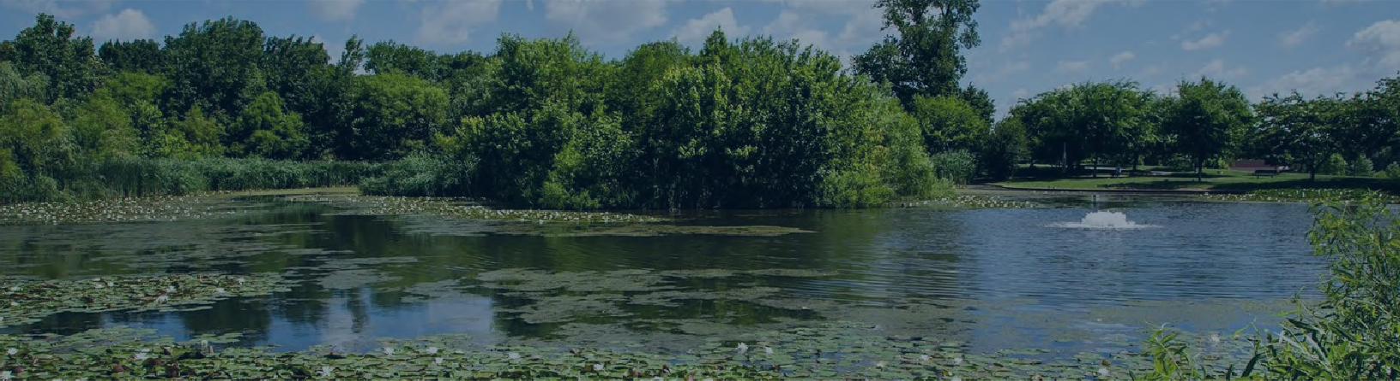

Baltimore is in desperate need of a government that runs efficiently and provides reliable, quality services. Across our city, you will encounter overflowing trash cans, dumped debris, and litter in our streets and waterways.

We need common sense solutions to clean up our city.

2X Twice weekly trash pick up at community request Double the number of trash cans on the streets

A+ Establish Clean Streets Index, grading cleanliness of every city street Make dumpsters available for community weekend clean ups

Use enhanced technology to crack down on illegal dumping

Ensure Citizen Drop-Off Centers are open seven days a week

Develop Materials Recovery Facility and a circular economy around City waste

***CONNECTING BALTIMORE***

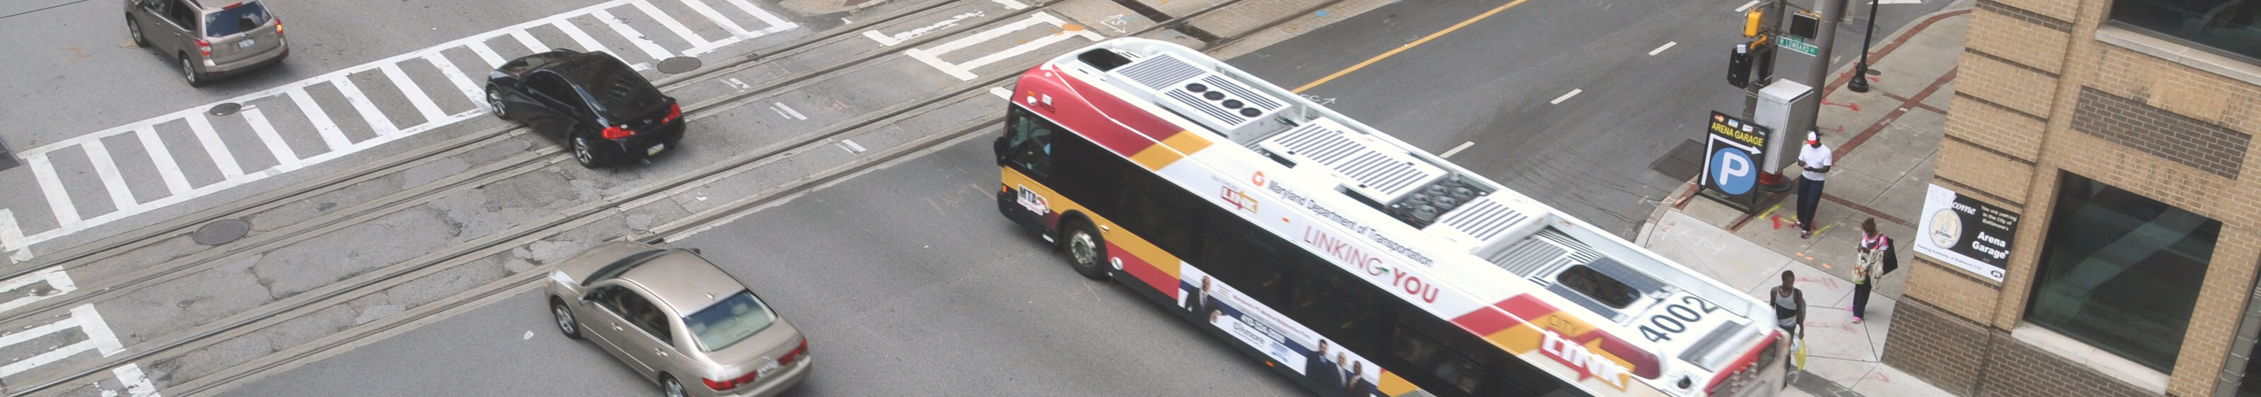

Baltimore should be a defining example of a green and equitable transit system. Current transit deficits correspond to a history of unbalanced economic investments, a backwards approach to sustainability, inequitable distribution of affordable housing, and a failing education system. Together, we will reimagine a transit system for Baltimore with the mobility and needs of all residents in mind.

We will implement Complete Streets to rebuild our crumbling roads and bridges. This will enable safe pedestrian traffic across the city, including East-West avenues serving walkers, bikers, and those riding e-scooters.

In addition to designated bike lanes and green transit avenues, Thiru pledges to complete the Gwynns Falls and Herring Run Trails, which will establish a 35-mile trail loop that connects 80% of Baltimore’s neighborhoods to recreational greenspace.

Not only should a share of e-scooters be distributed to “equity zones” (a quarter are already required to be) — we will also designate parking areas, expand scooter and bike lanes based on scooter usage data, and require companies to automatically reduce prices in neighborhoods with public transit deficits.

A top priority will be to expand free bus circulator routes to include major west-to- east corridors and critical arteries to historically disinvested neighborhoods. This will lay the groundwork for a citywide free public bus system, which will reduce pollution as ridership increases, make the City more accessible, and reduce commute times.

The city that built the first leg of the American railroad should lead the charge to build the first leg of America's first high speed rail between Baltimore and D.C. To guarantee access to commuters of all income levels, the contracted operator will be required to cap the price of commuter passes as a percentage (1-3%) of annual income to ensure this is a transit option for everyone.

To operate in Baltimore City, ride share companies will be required to provide free or reduced fares for riders located in or traveling in transit deserts. Reduced fares will also be applied to trips to critical locations like public transit access points, grocery stores, pharmacies, and schools and community centers.





Paid for by Thiru Vignarajah for Baltimore Tunji Williams, Treasurer

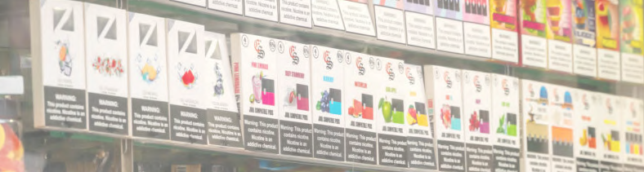

"Vignarajah’s aggressive plan to stop JUUL and the other tobacco companies will put Baltimore at the forefront of protecting the public from the dangerous and addictive e-cigarettes that are expanding the tobacco epidemic.”



*ENDING THE E-CIGARETTE EPIDEMIC*

Baltimore will ban flavored tobacco products including e-cigarettes

As the FDA and CDC have cautioned, flavored vaping and tobacco products, like cigarillos and menthol cigarettes, present a grave health risk, particularly to children. It is no accident the use of e-cigarettes and vapes among young people has exploded, as 7 out of 10 teens are exposed to e-cigarette ads. Major e-cigarette makers are pushing colorful tobacco products, using mobile platforms like YouTube and Twitter, and promoting teen-friendly flavors. Already, 13% of high school students use e-cigarettes—and more than

60 toxins have been identified in liquid flavored products. Baltimore should follow cities from San Francisco to Chicago to Minneapolis, which have prohibited flavored products to protect their citizens and children.

Enact complete prohibition of e-cigarettes in indoor public spaces

The CDC has reported that e-cigarettes not only contain nicotine, but also have lead, nickel, tin, volatile organic compounds, and diacetyl, a chemical linked to a serious lung disease. Secondary aerosol inhalation increases the risks of asthma in young children, sudden infant death syndrome, and respiratory symptoms and infections. Baltimore should build on its partial indoor prohibition, close the loopholes, and forbid smoking of e-cigarettes in all places cigarette smoke is banned, including bars and restaurants.

Initiate city lawsuit against e-cigarette manufacturer JUUL

New York City and DC recently filed major lawsuits against JUUL for illegally targeting youth and intentionally misleading consumers about the consequences of its products. According to the CDC, a single JUUL or e-liquid pod contains the same amount of nicotine as roughly 20 packs of cigarettes. Just as we sued drug companies for fueling the opioid crisis, Baltimore should join the movement of cities suing this industry for creating the latest youth health crisis.

Impose tax on e-cigarettes to fund children’s health screenings at city elementary schools

Like neighboring locales, Baltimore should impose a 50% wholesale tax on vaping products (between Montgomery County’s 30% and DC’s 96%), plus an additional $0.10/mL tax on e-liquids containing nicotine. The tax proceeds would pay for comprehensive health screenings of city elementary school children, as well as youth prevention efforts and treatment for those addicted.

Keep tobacco money out, refuse campaign donations from industry and lobbyists

Our campaign pledges to refuse political donations from tobacco and e-cigarette companies, as well as from their executives and lobbyists. The tobacco industry has made significant contributions to Baltimore leaders in order to block regulations that would protect our children from their harmful products. Citizens deserve to know that their health and safety comes first, not campaign finances and industry profits.

***“I want Baltimore to become the most inviting and hospitable city in the country for the LGBTQ+ community. No one should be judged for who they are or who they love. As a city, our policies, practices, and institutions must reflect that commitment.”***

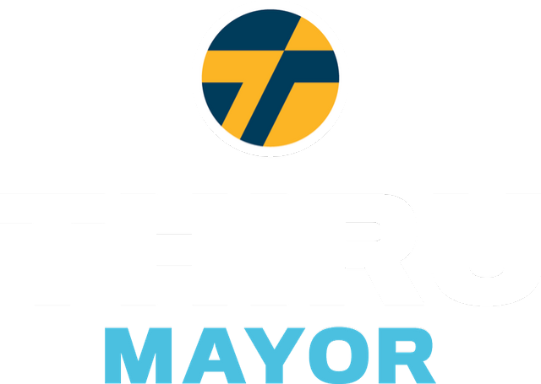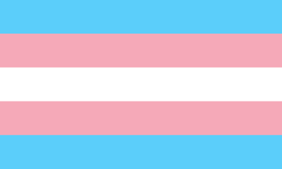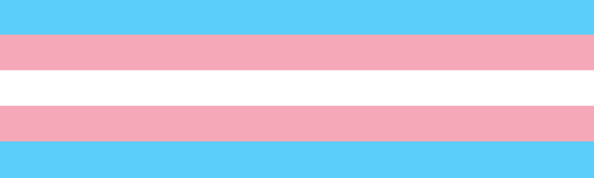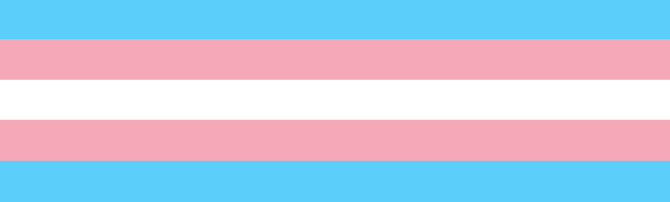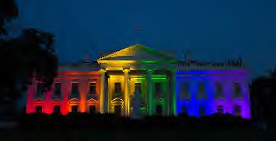

#### Thiru's policy framework for fighting discrimination and protecting the civil rights of LGBTQ+ citizens in Baltimore:

1. Promote LGBTQ+ owned small businesses, entrepreneurs, and city districts
2. Enable services to account for challenges facing LGBTQ+ youth in Baltimore
3. Prioritize inclusive workplace policies and trainings for all city employees
4. Appoint an official LGBTQ+ Liaison within the Mayor’s Executive Office
5. Address the needs of at-risk LGBTQ+ populations including veterans and seniors
6. Protect transgender citizens from crime and discriminatory police enforcement
7. Improve and expand health services for members of the LGBTQ+ community Broaden LGBTQ+ Commission’s responsibilities to include training and privacy- sensitive data collection for evidence-based policy making

8

Thiru, an advocate and ally, led the drafting of a report by the Maryland Attorney General, *The State of Marriage Equality in America*, which was cited by the Supreme Court in its landmark decision, *Obergefell v. Hodges.*



**Vignarajah Declares Solidarity, Announces Plans to Make Baltimore Most Inviting City in America for LGBTQ Community**

Our city has a vibrant and proud LGBTQ community. Thiru is dedicated to safeguarding their rights and fostering diversity and inclusivity within Baltimore. While Baltimore has made progress, members of the LGBTQ community continue to face systemic discrimination with regard to healthcare, housing, education, and employment, as well as in their day-to-day lives in the forms of stigmatization and outright violence. Thiru stands as a proud ally to the LGBTQ community and will work with local leaders to promote policies that account for the reality that discrimination manifests itself differently depending upon race, sexual orientation, and gender identity.

Thiru’s policy framework will focus on a range of issues important to Baltimore’s LGBTQ community

and aim to break remaining barriers to full equality, including:

1. Promote LGBTQ-owned small businesses, entrepreneurs, and city districts
2. Enable services to account for challenges facing LGBTQ youth in Baltimore
3. Prioritize inclusive workplace policies and trainings for all city employees
4. Appoint an official LGBTQ Liaison within the Mayor’s Executive Office
5. Address the needs of at-risk LGBTQ populations including veterans and seniors
6. Protect transgender citizens from crime and discriminatory enforcement
7. Improve and expand health services for members of the LGBTQ community
8. Broaden LGBTQ Commission’s responsibilities to include training and privacy-sensitive data collection for evidence-based policy making
9. **Promote LGBTQ-owned small businesses, entrepreneurs, and city districts**

Baltimore must invite small businesses and create business alliances across the board. That said, it can take steps to specifically assist and accommodate local LGBTQ-owned businesses as well. Thiru will incorporate LGBTQ-owned businesses into the incentive programs that function through the Office of Minority and Women-Owned Business Development, in order to rightfully acknowledge their role in providing services to the citizens of Baltimore and in creating a more inclusive, diverse space for community. Building on residential and commercial districts that serve and celebrate LGBTQ culture, Thiru will also prioritize city and private investment in welcoming, inclusive neighborhoods.

1. **Enable services to account for challenges facing LGBTQ youth in Baltimore**

*Protecting LGBTQ Identities in Schools*

In April of 2019, the Baltimore City Board of School Commissioners passed [Policy JBB](https://www.osibaltimore.org/2019/04/baltimore-city-school-board-passes-policy-to-protect-trans-students/), which ensures that transgender students have access to the restrooms of their preference and are referred to by the right gender/pronouns in class and on official documents and records. To make Baltimore’s public schools even more inclusive, Thiru will establish LGBTQ-inclusive curriculum and support LGBTQ youth anti-harassment campaigns.

*Catering Homeless Shelters to LGBTQ Youth*

According to a recent study, roughly [40%](https://nationalhomeless.org/issues/lgbt/) of the homeless youth population in the United States identify as LGBTQ. Thiru will employ the Mayor’s Office of Human Services to equip Baltimore’s pre-existing homeless shelters, along with transitional and supportive housing, with the resources to best serve LGBTQ youth, such as increased counseling staff, tailored job training, and access to health services.

*Founding a LGBTQ drop-in center*

The Department of Health and Human Services shows that LGBTQ individuals are far more likely to experience clinical depression and are roughly three times more likely to complete suicide. For these reasons, [New York City has just pledged 4.8 million dollars to opening a new 24 hour drop in center](https://www.aliforneycenter.org/programs/drop-in/) [for LGBTQ youth.](https://www.aliforneycenter.org/programs/drop-in/) Baltimore should follow the example of other cities and create its own drop-in center. The center would unite resources and actors, like schools and community organizations, around our LGBTQ youth.

1. **Prioritize inclusive workplace policies and trainings for all city employees**

Discrimination in the workplace is an unfortunate reality for many in the LGBTQ community. Baltimore City Agencies must take proactive steps to combat prejudice against their employees. In an effort to increase accountability and establish a welcoming, respectful environment for LGBTQ employees, Thiru will implement mandatory and recurring inclusivity training for city employees, beginning with new hires. The city’s existing LGBTQ Commission will head training efforts. In addition, Thiru will require there to be at least one gender-neutral bathroom in all city-owned buildings and adjust city government forms to include gender neutral language and non-binary identities.

1. **Appoint an official LGBTQ Liaison within the Mayor’s Executive Office:**

To increase the awareness of LGBTQ issues within the mayor’s executive office, Thiru will establish an official LGBTQ Liaison. The LGBTQ Liaison will convene with community members, local organizations, and relevant city entities to learn about the issues that Baltimore’s LGBTQ people face every day. The liaison will review city policies and services, communicate to government leaders when proposals fail to meet standards for LGBTQ equality, and serve as a resource for constituents who want to bring LGBTQ-related issues to city government but hesitate in fear of dismissal or misunderstanding. The appointed individuals would collaborate alongside the city’s existing LGBTQ Commission, its selected Chairperson, as well as the Liaison Officer within the Baltimore City Police Department.

1. **Address the needs of at-risk LGBTQ populations including veterans and seniors**

[Veterans who identify as LGBTQ face increased health risks and unique challenges in health care.](https://www.baltimoresun.com/health/bs-hs-elderly-lgbt-20150927-story.html) Thiru will lead Baltimore in conjunction with the Veterans’ Commission to collect data on LGBTQ veterans and provide them with the appropriate health benefits and services. He will also employ legal experts to aid veterans who were wrongfully subject to discrimination during service or the “Don’t Ask Don’t Tell” policy upon discharge.

Thiru will also strive to aid Baltimore’s senior LGBTQ population, who are more prone to health issues and suffer from rising housing costs. He will prompt the LGBTQ Commission and LGBTQ Liaison in the Executive Office to advocate on behalf of the senior LGBTQ population, push for affordable housing options, and inform senior-care facility managers, employees, and residents of relevant anti-discrimination laws.

1. **Protect transgender citizens from crime and discriminatory enforcement**

The nationwide surge in violent hate crimes against the transgender community is both heartbreaking and unacceptable[.](https://www.hrc.org/blog/hrc-mourns-tydi-a-black-transgender-woman-killed-in-baltimore) [Baltimore has seen multiple incidents of transphobic related violence.](https://www.hrc.org/blog/hrc-mourns-tydi-a-black-transgender-woman-killed-in-baltimore) Thiru will work with the LGBTQ Commission Chairperson, the LGBTQ Liaison to the Executive Office, and LGBTQ Liaison Officer to bolster relationships between law enforcement and the transgender community. Further measures include 1) requiring the LGBTQ Officer to submit statistics and reports on LBGTQ-related crimes to the Mayor’s Office, 2) monitoring the Police Department’s fulfillment of and training related to [Policy 720](https://www.baltimorepolice.org/sites/default/files/Policies/720_Lesbian_Gay_Bisexual_And_Transgender_Involved_Incidents_0.pdf) [(2018 draft here](https://www.powerdms.com/public/BALTIMOREMD/documents/349766)) and 3) incorporating recruitment of LGBTQ individuals into Baltimore’s police force within crime policy proposals and halting discriminatory practices such as unnecessary trespass and loitering arrests.

1. **Improve and expand health services for members of the LGBTQ community**

*Mental Health*

[LGBTQ individuals, especially youth, are more than twice as likely to suffer from a mental health](https://www.psychiatry.org/File%20Library/Psychiatrists/Cultural-Competency/Mental-Health-Disparities/Mental-Health-Facts-for-LGBTQ.pdf) [condition compared to non-LGBTQ identifying individuals.](https://www.psychiatry.org/File%20Library/Psychiatrists/Cultural-Competency/Mental-Health-Disparities/Mental-Health-Facts-for-LGBTQ.pdf) Thiru will provide more accessible and affordable mental health services tailored to the LGBTQ community under a new mental health program within the Baltimore City Health Department. This initiative will create a new LGBTQ- specific mental health hotline and foster partnerships with school counselors and youth centers/organizations to provide mental health resources where currently insufficient.

*Appropriate/Inclusive Treatment and Care*

Often a doctor’s office can be an uncomfortable and vulnerable space for LGBTQ individuals. Thiru will encourage efforts to provide inclusive medical care to members of the LGBTQ community, following models similar to Johns Hopkins’ “Embracing the Rainbow” program. These initiatives will encourage respectful communication between LGBTQ patients and medical professionals, and emphasize training focused on gender-neutral questioning and non-binary options to medical inquiries.

*Partnerships with Health Professionals*

Institutions such as the Baltimore City Health Department and the Mayor’s Office of Human Services will partner with local healthcare providers, state and federal agencies, and community groups to promote LGBTQ health and foster efficient collaboration. Health issues such as HIV prevention and treatment will receive particular attention.

1. **Broaden LGBTQ Commission’s responsibilities to include training and privacy-sensitive data collection for evidence-based policy making**

In early 2018, Baltimore City passed an executive order to create a city-sponsored LGBTQ Commission, which comprises 15 community members who offer insights and recommendations to promote the prosperity of LGBTQ Baltimoreans. This executive order was a vital decision to further equality-driven policymaking, but there is more we can do to integrate and support the Commission. Thiru would expand its responsibilities, while ensuring access to required resources. The Commission would lead research on issues pertaining to the community and manage inclusivity and diversity training for city employees and external parties.

Too often we fail to collect LGBTQ specific data to inform the allocation of resources, rendering the massive disparities experienced by members of the LGBTQ community — particularly transgender people — invisible to policymakers. With the Commission’s help, Baltimore can study, investigate, and close the gaps in health, income, and well-being outcomes that the LGBTQ community experiences, collecting data that respects individual and community privacy. Involvement through government or third-party training, in schools or medical facilities, will heighten the Commission's visibility and fulfill an essential arm of community outreach.

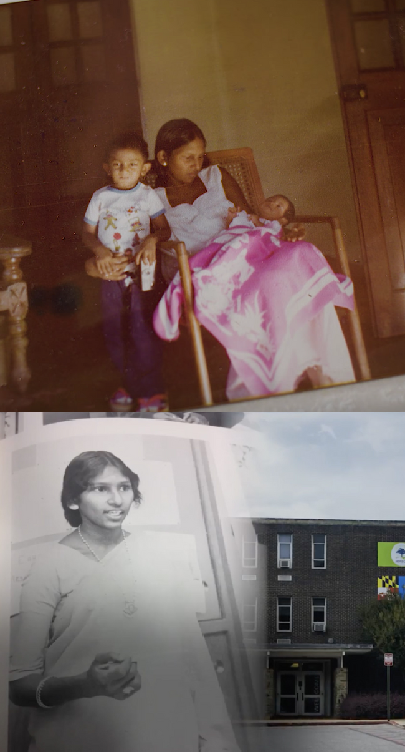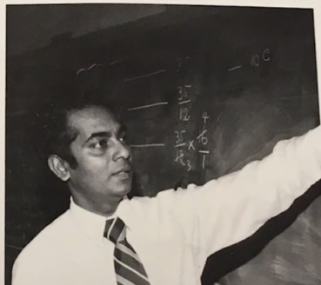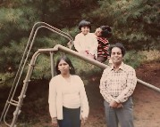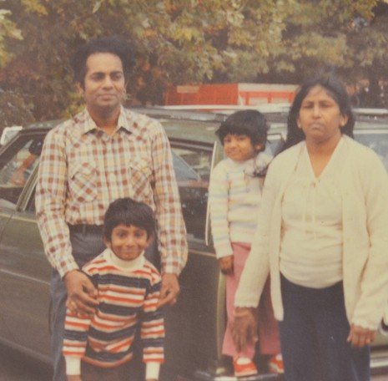

*Aspiring to become the most inviting and hospitable city in the country for immigrants and refugees, Baltimore should be the Plymouth Rock and Ellis Island of the next century."*

*Thiru's Plan to Safeguard & Support Immigrants*

Thiru's family fled a civil war and came to Baltimore when he was three. Both dedicated city school teachers, his mother taught at Poly and Morgan State, and his father taught at Edmondson, Douglass, Southern, and Western. His family's commitment to public service is not an unfamiliar story. Immigrants have always been an essential force in forging Baltimore’s vibrant culture and history. Thiru strives to make Baltimore welcoming to immigrants from all around the world: a place to raise their families, build a life, and call their home.

*This is not just the American Dream – it is the Baltimore Dream too.*

Guarantee Legal Proceedings & Right to Counsel

Amend the city charter to guarantee legal proceedings and a right to counsel, with a translator if neccessary, for those who face deportation

No Support for ICE

Promise no money or effort will be directed towards supporting ICE

Bar ICE from sensitive locations like places of worship, hospitals, and courthouses Encourage victims and witnesses to cooperate in human trafficking, violent crime, and domestic violence cases

Prioritize Civil Resolution & Recruit Immigrant Officers

Work with state government to direct police to pursue civil remedies/diversion options prior to arrest for non-violent offenses where deportation is a disproportionate response Recruit more immigrant police officers and remove bar on permanent residence

Invite Cultural Exchange

Hold events to celebrate Baltimore's immigrant populations Offer more affordable language classes for community members

Establish H-1B Visa Matching Program

Pair immigrant workers with local employers, non-profits, and municipal agencies

Heighten Representation & Outreach

Appoint liaisons/translators to speak to City Hall on behalf of community advisory boards

Improve coordination within the Mayor's office to offer consistent, quality, and easily- accessible resources to programs and information

Expand Municipal ID Program for Non-Citizen Residents

Broaden access to city-run assistance by providing valid ID to non-citizen residents Secure non-resident participation in decisions regarding the local school board

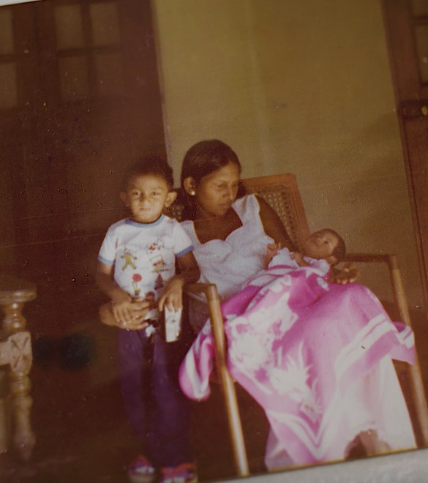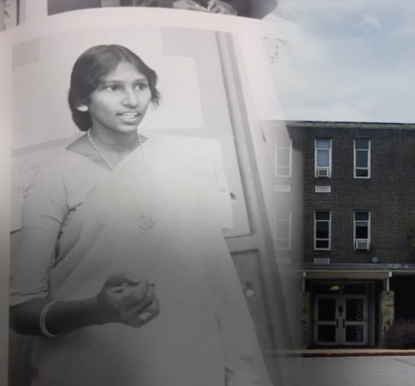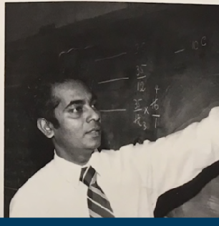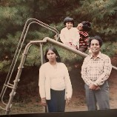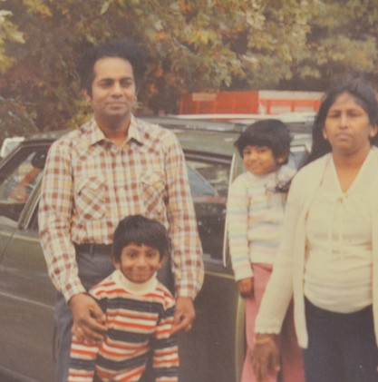

*Aspirando a ser la ciudad mas atractiva y hospitalaria en el país para los inmigrantes y refugiados, Baltimore debería ser el Plymouth Rock y Ellis Island del próximo siglo.*

*El Plan de Thiru para Asegurar y Auydar a los Inmigrantes*

La familia de Thiru escapó de una guerra civil y vino a Baltimore cuando él tenía tres años. Sus padres eran maestras dedicadas en la ciudad, su madre trabajó en Poly y Morgan State, y su padre trabajó en Edmondson, Douglas, Southern, y Western. El compromiso de su familia al servicio publico no es una historia desconocida. Los inmigrantes siempre han sido una fuerza esencial, forjando la cultura vibrante y la historia de Baltimore. Thiru se esfuerza para hacer de Baltimore una ciudad acogedora a los inmigrantes de todo el mundo: un lugar para crecer a la familia, construir una vida, y llamarlo hogar.

*No es simplemente El Sueño Americano, es El Sueño de Baltimore también.*

Garantizar Procedimientos legales y el derecho al consejo

Enmendar la Carta de la Ciudad para garantizar procedimientos legales y el derecho al consejo, con derecho a servicios de traducción, para aquellos en peligro de deportación.

No apoyo para ICE

Ni fondos ni esfuerzos serán proporcionados al ICE.

No permitir que ICE entre en locales sensitivos como iglesias, hospitales, y cortes.

Apoyar las victimas y los testigos a cooperar en casos de la trata de personas, de crimen violenta y de la violencia doméstica.

Dar prioridad al remedio civil & recultar policías inmigrantes

Trabajar con el gobierbo estatal para hacer que la policía recurra al remedio civil y desvío previo al arresto para las ofensas no violenta donde la deportación es una respuesta desproporcionada.

Contratar con mas inmigrantes para ser policía y quitar el requisito de residencia permanente

Invitar intercambio cultural

Tener eventos para celebrar la población inmigrante de Baltimore.

Dar mas clases de lenguaje económico para miembros de la comunidad.

Establecer un programa coincidente de H-1B Visa

Acoplar trabajadores inmigrantes con empleadores locales, las organizaciones sin fines de lucro, y agencias municipales.

Crecer la representación y programas de divulgación

Nombrar contactos y traductores para hablar con la alcaldía en los consejos consultivos de la comunidad

Mejorar la coordinación con la oficina del alcalde para dar recursos constantes, de calidad, y fácilmente accesible para programas y información

Ampliar el programa de identificación municipal para residentes no ciudadana

Ampliar el acceso a la ayuda de la ciudad dando identificación válida a los residentes no ciudadanos

Asegurar la participación de la gente no residente en las decisiones que afectan a las escuelas locale

*SQUEEGEEING ALTERNATIVE PLAN*

Squeegeeing emerges from the complex problems that have plagued Baltimore for generations: a lack of economic opportunity, unaccountability in our broken public schools, a sweeping opioid epidemic, and rampant crime that disproportionately affects Black and Brown communities. Getting individuals off the streets and into well-paying, stable jobs, as well as connecting them to the resources they need, will require a multifaceted, comprehensive approach.

Squeegee boys are not one monolithic group. These individuals have unique motivations and needs that prompt their decision to turn to squeegeeing. We see three distinct categories of individuals and realize each will require a personalized engagement strategy:

Those who squeegee to provide for themselves and their families

Victims of addiction, mental illness, or have backgrounds impacted by substance abuse

Those who are committed to squeegeeing regardless of diversion attempts

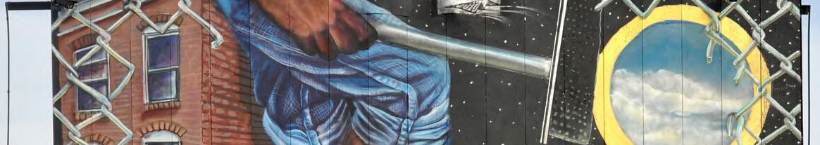

Open pathways for advancement in education or employment Provide health, addiction, housing, or job placement services Take the tools of their trade to raise the cost of doing business



**FROM SQUEEGEES TO SAFETY AND SUCCESS**

Squeegee boys have become, fair or not, a symbol of Baltimore’s current plight. To some, they are an unfortunate marker of a city led by complicit politicians and failing schools that do not provide people, youth especially, with meaningful job opportunities and career advancement pathways. For others, they represent a menacing presence that deters them from bringing their families downtown. At a different time in Baltimore’s history, these squeegee workers would not pose such a challenge to residents and elected officials. However, with record violence, they are an ever-present reminder that Baltimore’s leaders are failing to connect the dots and support the individuals who may need it most.

We know that interactions between drivers and squeegee boys can turn aggressive. In January 2020, we saw the heart-wrenching video of a man senselessly beaten by squeegee boys on the corner of President and Lombard. Not only do commuters feel threatened, but squeegee boys also put themselves into danger darting in between busy traffic. In October of 2018, a ten-year-old squeegee boy was injured after being struck by a car; in 1986, a fourteen-year-old squeegee boy was fatally hit by a vehicle. City Hall has yet to move the needle in a way that instills confidence that we can avoid another tragedy — we don’t need another incident to learn from our past.

Squeegeeing emerges from the complex problems that have plagued Baltimore for generations: a lack of economic opportunity, unaccountability in our broken schools, a sweeping opioid epidemic, and rampant crime that disproportionately affects black and brown communities. Getting individuals off the streets and into well- paying jobs, as well as connecting them to the resources they need, will require a comprehensive approach.

**Identify What Drives Individuals to Squeegeeing**

Squeegee boys are not one monolithic group. These individuals have unique motivations and needs that prompt their decision to turn to squeegeeing. Thiru and his team see three distinct categories of individuals and realize each will require a personalized engagement strategy:

1. Those who squeegee to provide for themselves and their families
2. Those who squeegee and are themselves struggling with addiction or mental illness or come from backgrounds impacted by substance abuse
3. Those who will attempt to continue squeegeeing regardless of diversion attempts

Baltimore’s existing programming and services are disjointed and do not sufficiently provide the wraparound care that will lead to sustainable outcomes. To best engage with squeegee workers, we need to personally meet them where they are. Squeegeeing is limited to the few corners with the highest traffic volume. Our team went to the street corners, collected anecdotal evidence, and spoke with these young people, realizing that squeegeeing primarily occurs on fourteen corners:

**Map of Top Squeegee Locations as identified by the Thiru for Baltimore Team**

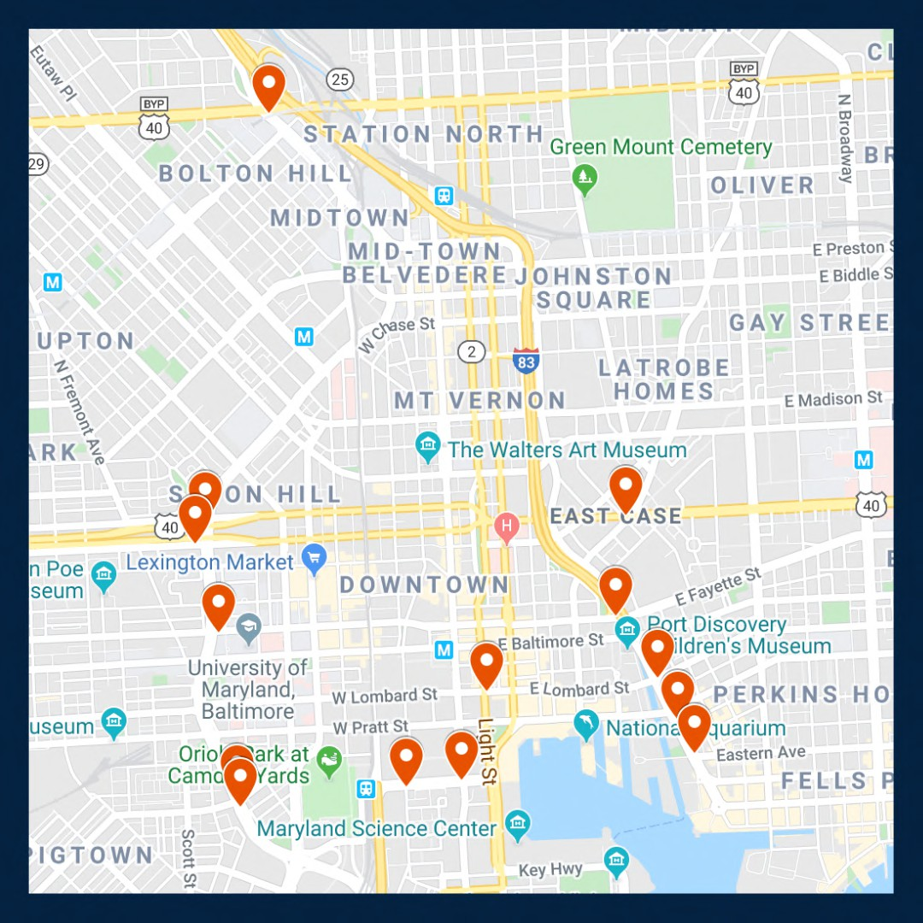

As mayor, Vignarajah pledges to:

1. Ensure squeegee boys are aptly connected to pathways to advance their education or gain secure employment with advancement opportunities
2. Recognize squeegee boys with addiction, mental illness and/or homelessness limitations that require health, addiction, housing, or job placement services and promptly facilitate access to those programs
3. In unique cases, where individuals will continue to turn to squeegeeing regardless of alternative options, take the tools of their trade to raise the cost of doing business

**Create Alternative Work Programs that Compete with the Benefits of Squeegeeing**

*Facilitate Job Interviews Between Squeegee Boys and Local Businesses*

City leaders cannot pretend that creating a stable nine-to-five job that pays $15 an hour, before taxes, can ever compete with the perks of being a squeegee boy. We must acknowledge that they can in some instances make

$30 to $50 an hour, can come and go as they please, and report to no one but themselves. Nevertheless, we must present an alternative employment opportunity that is attractive to these young people.

Thiru has already started partnering with local businesses to provide squeegee boys with secure employment and in turn, advancement opportunities. Thiru will hire liaisons to assist squeegee boys interested in pursuing a stable, permanent career and connect them with local businesses that are willing to offer employment. While meaningful employment may present new challenges to these individuals, it can teach valuable skills, such as how to build a schedule, how to remain accountable to a team, how to build a relationship with a supervisor, and how to follow codes of conduct. The greatest opportunity provided by employment in local businesses is upward mobility. These opportunities will open an avenue for progression otherwise difficult to obtain for many of these young men, and certainly not available on a street corner.

We have refused to wait for city politicians to take action, or even for the election, to implement a program that can provide immense benefits for our economy and these young men. Squeegee boys and local businesses interested in participating should email [opportunity@thiru2020.com.](mailto:opportunity@thiru2020.com)

**Station Unarmed, Site-Specific, Deputized Community Liaisons at the Busiest Corners**

*Bring Resources to Street Corners*

Deputized community liaisons will positively interact with squeegee boys in their designated zone, building relationships and trust. Liaisons will not take away resources from our struggling police force -- instead, these liaisons will receive specific training on de-escalation techniques, and curate a specific policy for positive and appropriate engagement with squeegee boys.

Part of this positive engagement will include identifying school-aged individuals, in partnership with the relevant schools and after-school employment or programming, where applicable, who should be required to return to their education. Each deputized liaison will receive access to point contact information for all middle and high schools in Baltimore City. The City can encourage and support heightened collaboration between the liaisons and educators/administrators to redirect these young squeegee boys back to the classroom, while making sure their needs are met and they have the guidance, resources, and support to thrive.

These deputized community liaisons would also be trained on identifying vulnerable individuals in need of social services and City programs. They will receive training on recognizing who is suffering from food insecurity, addiction and mental illness, or housing troubles, so as to connect those individuals to appropriate experts and resources. This will take the form of Seattle’s Law Enforcement Diversion Programs (LEAD) which provides a credible alternative to booking individuals with behavioral health needs for low-level offenses. Instead of creating criminal entanglements, LEAD diverts these individuals to community-based interventions including housing, addiction, mental illness and health services.

*Raise the Cost of Doing Business*

Baltimore’s squeegee boys are making calculations on how to make ends meet. Some will not be receptive to alternative job opportunities because of the lucrative cash flow squeegeeing provides. That being said, we need to change the calculation by not only introducing consistent and favorable options for skill development and upward mobility, but also by increasing the cost of doing business in the streets by confiscating the tools of their trade. In accordance with the Baltimore City Code and working in conjunction with Community Liaisons; site-specific, unarmed private security guards who have been temporarily granted limited policing power will have the ability to confiscate squeegees. They will have no authority beyond their stationed corners, but this narrow power will raise squeegee boys’ opportunity costs. Article 19, Section 47-4 of the code grants police the authority to restrict solicitation “from any operator or occupant of a motor vehicle that is in traffic on a public street, whether in exchange for cleaning the vehicle’s windows or otherwise.”

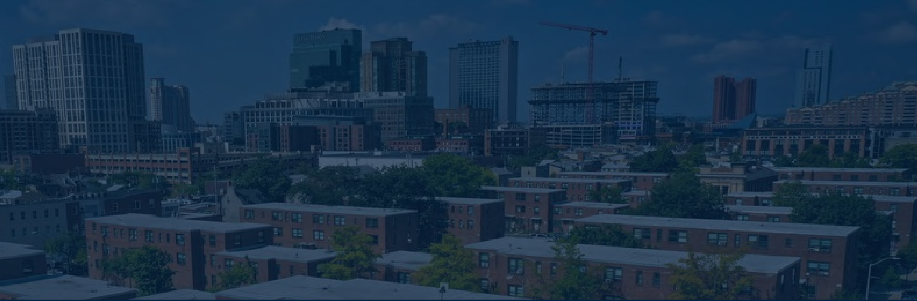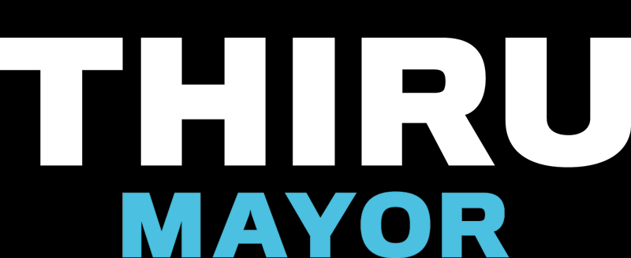

LEGALIZING CANNABIS IN BALTIMORE

The marijuana marketplace in Baltimore is currently a chaotic free-for-all. The illegal trade contributes to record violence, and the medical trade is not taxed. Mayoral Candidate Thiru Vignarajah has pledged to make Baltimore the first city in America to regulate and tax marijuana without waiting for federal or state approval.

# Devote Tax Revenue to Public Education Priorities

All City revenue would be directed exclusively to key education programs:  Universal pre-K for every 3- and 4-year-old child

 Debt-free higher education for public high school graduates, including trade school  Funding to grow the endowments of HBCUs

# Establish City Agency to Manage the New Market

Appoint board members who will develop permit criteria; fix taxes and regulations; and issue growth, processing, sale, and “cannabis café” permits

Create a safety board that will ensure recreational cannabis is safe and free of dangerous additives

# Guarantee Access and Equity for Communities of Color

Frustration continues to grow as communities of color—who disproportionately



shouldered the burdens of the failed War on Drugs—are now being effectively excluded

from the profitable new market. Baltimore will

issue

by

permits preferentially to

enterprises

owned,

operated,

and

controlled

historically-disadvantaged

minorities and those who commit to hire returning citizens with non-violent criminal

records seeking constructive employment.

Establishing a legal cannabis market in Baltimore would

produce $250 million in annual revenue for the City.



**Reduce Crime, Create Jobs & Increase Investments in Education**

**by Regulating and Taxing Baltimore’s Marijuana Market**

*Mayoral candidate Thiru Vignarajah announced a bold plan to issue permits and tax the cannabis trade in Baltimore to reduce crime, create well-paying jobs, reduce overdoses, and fund universal pre-K for every Baltimore child.*

The marijuana marketplace in Baltimore is currently a chaotic free-for-all. The illegal trade contributes to record violence while depriving taxpayers of hundreds of millions of dollars. The illegal street market operates unimpeded as police and prosecutors publicly squabble about whether to enforce current laws, even as street marijuana is increasingly laced with fentanyl and K-2. Medical cannabis is booming but cannot be taxed and has virtually no licensed distributors of color.

Bottom line: a billion dollars is spent on cannabis products each year, which largely ends up in the monopoly hands of untaxed licenses and violent gangs and drug organizations.

This is the worst of all worlds. Violence is unabated; avoidable overdoses persist; and drug proceeds remain locked in a violent black market. Moving the cannabis trade into a well-regulated, transparent market and out of the shadows will (1) reduce gun violence driven by competing gangs, (2) decrease overdose deaths from laced marijuana, (3) reduce opioid addiction and overdoses; (4) mitigate the racial wealth gap, and (5) provide vital revenue to fund universal pre-K, finance repairs and upgrades at K-12 school facilities, guarantee free college in Maryland for public school graduates, and grow HBCU endowments. Baltimore City cannot afford to wait for indecisive lawmakers in Annapolis to take action while the City suffers from the failed war on drugs.

Just as Colorado and other states have issued permits and taxed the sale of cannabis, even though it remains illegal under federal law, so too should Baltimore City issue sales permits and tax cannabis. The same people who think Baltimore City has to wait for Maryland law to change thought Colorado had to wait for federal law to change. It’s time for Baltimore to lead, not follow.

**Issue Permits to Baltimore Businesses to Aid Communities of Color**

When it comes to marijuana, the war on drugs has been a colossal failure. For decades, communities of color have disproportionately shouldered the costs of Baltimore’s enforcement policies. The communities who were most devastated by the failed policies of the 1980s ought to be the first to benefit from this emerging market.

* Permits will be preferentially issued to enterprises owned, operated, and controlled by historically disadvantaged business owners of color.
* Permits will be issued to distributors owned, operated, and controlled by local businesses.
* Permits will be preferentially issued to enterprises who commit to hire employees with non- violent criminal records who are seeking legitimate employment opportunities.

**Require Tax Proceeds be Spent Strictly on Public Education Programs**

The emerging cannabis market would produce $250 million in annual revenue for Baltimore City. Maryland and neighboring states will inevitably legalize marijuana, but there is a first-mover advantage in this industry that the City should seize. In the past, residents have been promised funds for education from controversial ventures like casinos only to see money diluted or redirected to other priorities. This won’t happen again.

* All cannabis tax proceeds will be strictly dedicated to key education programs, starting with

(1) universal pre-K for every 3- and 4-year-old child, (2) repairs and improvements at K-12 facilities, (3) debt-free 4-year college, community college, or trade school for Baltimore public high school graduates, and (4) funding to grow the endowments of HBCUs.

* These funds will be used only to support new programs and to supplement, not replace, current funding sources for the expansion of existing programs.

**Establish Infrastructure to Manage Complex Emerging Market**

* The City will establish a commission composed of community members, with no conflicts, who will manage and make permitting decisions. The process and decision-making will be fully public and transparent so there are no doubts who made the decision and why.
* The City will create a city-operated credit union that holds the proceeds of cannabis sales, collects taxes and distributes them immediately to vital education programs, and eventually makes its reserve funds available for low-interest student and small business loans.
* The City will create a safety board that will ensure that recreational cannabis is safe and free of dangerous additives like fentanyl and will create and communicate clear regulations about when, where, and how the product can be sold and used.

In theory, in states like Colorado, prosecutors could bring charges under federal drug laws anytime. In practice, they never have. The premise of the proposed approach is that prosecutors in Baltimore have better things to do with their time than to go after permitted, minority-owned cannabis dispensaries based in Baltimore who hire residents desperately trying to obtain legitimate employment to turn their lives around. Issuing city permits and collecting taxes would no more make the sales legal under state law than issuing state licenses makes the sales legal under federal law. But, with ingenuity and leadership, we can still bring the marijuana trade out of the dangerous shadows—where gangs kill over turf—and create a safer market that redresses racial inequities and generates massive tax revenue at a time when Baltimore desperately needs it.

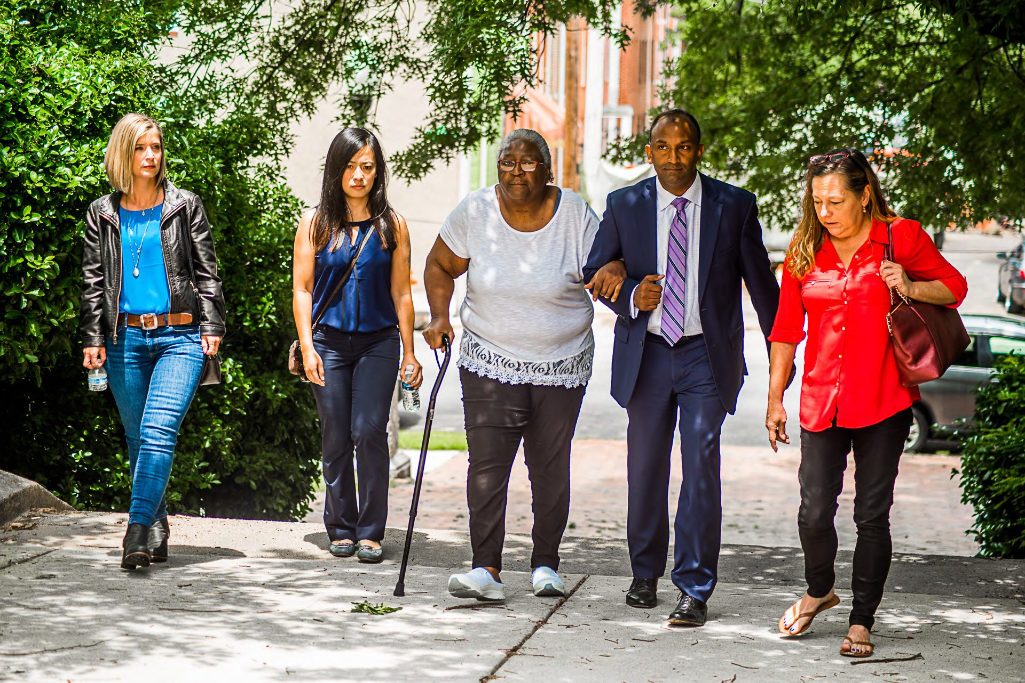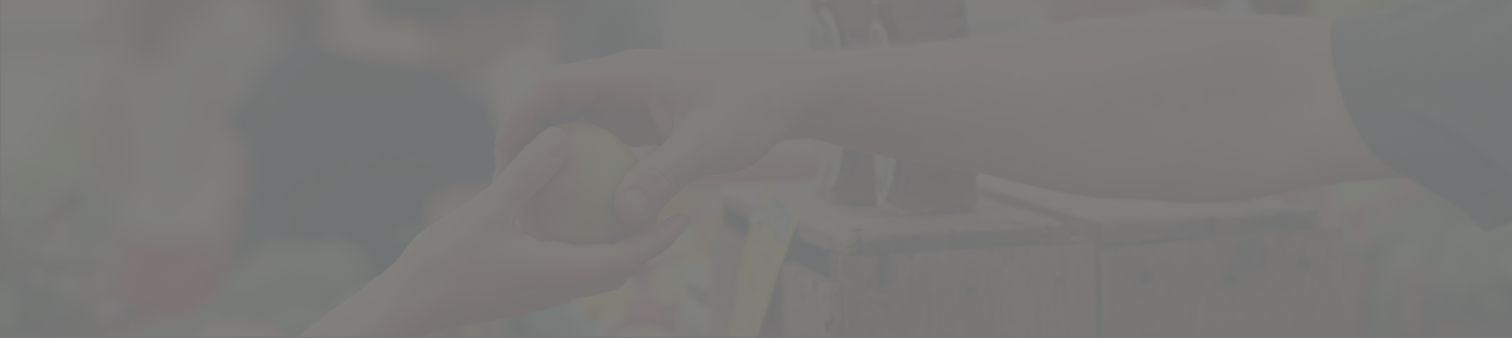

Backing Baltimore's Businesses

If Baltimore is to become the city it’s destined to be, the backbone of its economy must be small businesses. Here are Thiru's key priorities and concrete ideas to foster a welcoming, sustainable environment where businesses can thrive today and tomorrow...

#### Guarantee Public Safety

Create a safe and secure atmosphere around businesses by ensuring sufficient public and private policing

Reduce crime around businesses by providing incentives to purchase, install, and register cloud-based security cameras

#### Reduce the Costs of Doing Business in Baltimore

Cut property taxes in half over a period of ten years End minor privilege and permitting fees

Expand free parking near shops and restaurants Introduce low-interest rainy day loans for small businesses

#### Encourage Entrepreneurship, Diversity & Innovation

Pledge health insurance coverage for up to seven employees for companies that stay in Baltimore for at least five years

Recruit small businesses with a national marketing campaign

Provide tax incentives to encourage growth of small businesses owned and operated by minorities, women, members of LGBTQ and immigrant communities

YOUR DREAM HOME IS

WAITING FOR YOU.

LOCATED AT 2749 CONIFER DRIVE EVERETT, WA

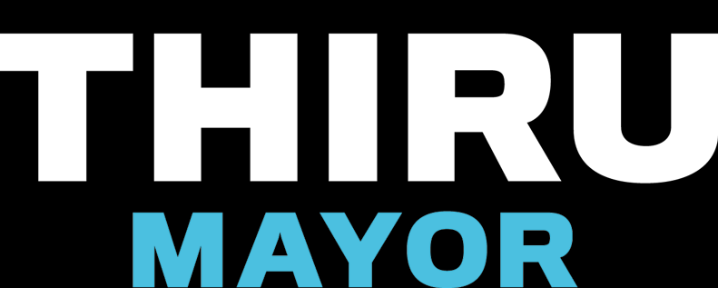

From The Wire to Veep, from the Star Spangled Banner to jazz, Baltimore’s rich history in art, film, and music is a source of pride and engine for growth.

Baltimore has all the promise to once more be a leader in the arts. But building an economy around art, film, and music will not happen on its own. City Hall must play a central role to ignite this industry.

THIRU'S PLAN TO REVITALIZE THE ARTS IN BALTIMORE

Expand and support the creation of additional arts and entertainment districts in addition to Station North, Highlandtown, and Bromo Tower

Extend tax-free income benefits in art districts to cover more artists, including, for example, musicians, spoken-word performers, and filmmakers

Create an "artists in residence" program. Participating artists and musicians would receive healthcare and a stipend in exchange for committing to teach their art in public schools and promote art in Baltimore's communities

Lead a capital campaign to raise funds from private donors in order to reinforce the shaky financial foundation of the Baltimore Symphony Orchestra

Re-establish incentives to encourage television producers and filmmakers to set their works in the city

Launch a mural initiative that matches local artists, potential donors, and community hosts to collaboratively beautify Baltimore



APPENDIX